Terraform State

We created a resource by terraform apply
When we rerun terraform apply – it will not create a resource, bcz, it knows the resource is existing.
How Terraform knows the resource is Existing or have to update the resource?

The file called terraform.tfstate in your configuration directory where your .tf file.

When you open terraform.tfstate file , you will get all statement about the resource are created.
Resource content --
resource filename --
Resource attribute
.tf file
all things

when you run terraform apply command ,
terrafom will check your config file main.tf , variable.tf etc for check for any update.
It will check the resource has been created , it’s attribute etc in terrafom.tfstate file.key.
If your main.tf file & terrafom.tfstate file has been match ( no any update P ) it will not create resource.

If your main.tf file & terrafom.tfstate file has been mismatch ( has any update ) it will recreate resource.

Purpose of State

Ex. you created lot of resources by lot of resource type and resource provider and name.

When you run terrafom plan or terrafom apply
it will fetch data about directly from terrafom.tfstate file & not by reconsole or reconnected.

So you will get info about terrafom plan or terrafom apply immediatly .

Terraform stores a cache of attribute values for all resources in the state.
We can specifically make terrafom to refer to the state file alone while runnig commands and having to refresh state file every time.

Use, terrafom plan - -refresh-false , terrafom apply - -refresh-false

Terraform State Considerations
1. terrafom.tfstate file contents sensitive informations at every details of your infrastructure.
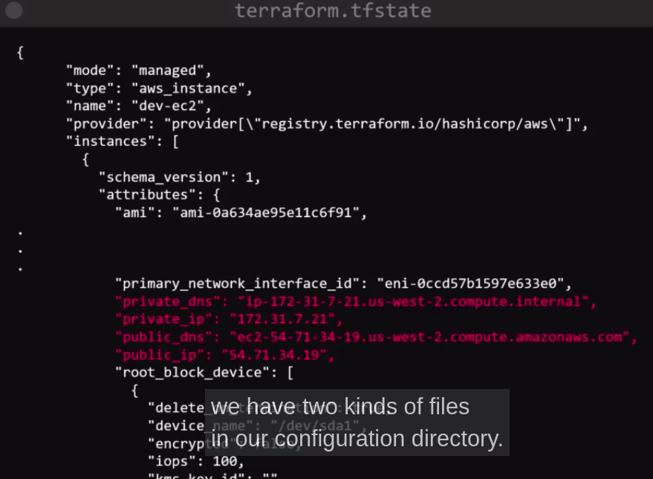

Here, you can see sensitive informations about EC2 Instance.
So, anybody can see this sensitive informations.
To protect this file you have to store this state file into secure storage.

You have to store your configuration file & terrafom.tfstate file on secure storage locations such as GitHub, GitLab, VersionControl, BitBucket.

You have to assign the owner of this sensitive file .
Who will owner
terrafom state file in a plain JSON file
We should never manually attempt to edit the state files ourselves.

